Source Data Mapping Approach to CDMV5.4

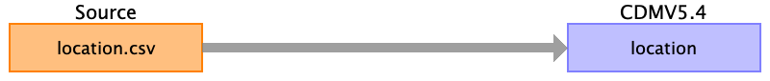

Table name: person

Table name: observation_period

Table name: visit_occurrence

Table name: visit_detail

Table name: condition_occurrence

Table name: drug_exposure

Table name: procedure_occurrence

Table name: device_exposure

Table name: measurement

Table name: observation

Table name: death

Table name: note

Table name: note_nlp

Table name: location

#Ein Kerem

location_id = 1

address_1= 'Kalman Ya'Akov Man St.'

address_2=

city='Jerusalem'

state=

zip=9574869

county = 'Israel'

location_source_value=''"

country_concept_id=41995088

country_source_value='Israel'

latitude=31.764967

longitude=35.150014

#Har HaTsofim

location_id = 2

address_1= '8 Churchill Avenue'

address_2=

city='Jerusalem'

state=

zip=9765422

county = 'Israel'

location_source_value=''"

country_concept_id=41995088

country_source_value='Israel'

latitude=31.798094

longitude=35.242217

Reading from location.csv

Generated

|  |  |  |  |
| --- | --- | --- | --- |
| Destination Field | Source Field | Logic | Comment |
| location_id |  |  | #Ein Kerem  location_id = 1  #Har HaTsofim  location_id = 2 |
| address_1 |  |  | #Ein Kerem  address_1= 'Kalman Ya'Akov Man St.'  #Har HaTsofim  address_1= '8 Churchill Avenue' |
| address_2 |  |  |  |
| city |  |  | name : 'Jerusalem' |
| state |  |  |  |
| zip |  |  |  |
| county |  |  | name : 'Israel' |
| location_source_value |  |  |  |
| country_concept_id |  |  | concept_id = 41995088 |
| country_source_value |  |  | 'Israel' |
| latitude |  |  | #Ein Kerem  latitude:31.764967  #Har HaTsofim  latitude:31.798094 |
| longitude |  |  | #Ein Kerem  longitude:35.150014  #Har HaTsofim  longitude:35.242217 |

Table name: specimen

Table name: fact_relationship

Table name: care_site

Table name: provider

Table name: payer_plan_period

Table name: cost

Table name: drug_era

Table name: dose_era

Table name: condition_era

Table name: episode

Table name: episode_event

Table name: metadata

Table name: cdm_source

Table name: cohort

Table name: cohort_definition

Appendix: source tables

Table: location.csv

|  |  |  |  |
| --- | --- | --- | --- |
| Field | Type | Most freq. value | Comment |
| name | INT |  |  |